5. Project Folder Structure

5.1 Structure 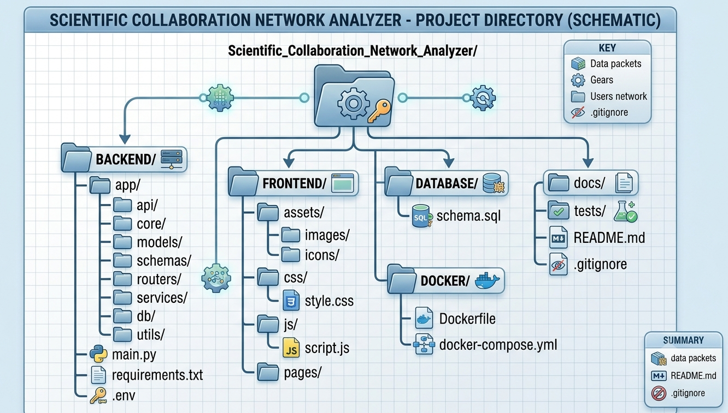5.2 Purpose of Each Folder
Folder / File | Purpose
backend/app/api/ | Aggregates and exposes API route groups to the main application.
backend/app/core/ | Holds core configuration: settings, security utilities, JWT handling.
backend/app/models/ | SQLAlchemy ORM models representing database tables.
backend/app/schemas/ | Pydantic schemas for request validation and response serialization.
backend/app/routers/ | FastAPI route handlers, one file per module (users, publications, etc.).
backend/app/services/ | Business logic layer that routers call into, keeping routers thin.
backend/app/db/ | Database session management and connection setup.
backend/app/utils/ | Shared helper functions (validators, formatters, file handling).
backend/main.py | Application entry point that initializes and runs the FastAPI app.
backend/requirements.txt | Python dependency list for the backend.
backend/.env | Environment variables (database URL, secret keys) — excluded from version control.
frontend/assets/ | Static images and icons used across the UI.
frontend/css/ | Stylesheets for the application.
frontend/js/ | Client-side JavaScript logic and API calls.
frontend/pages/ | Individual HTML pages for each module/screen.
database/schema.sql | SQL script defining the PostgreSQL schema (tables, keys, constraints).
docker/Dockerfile | Instructions to build the application container image.
docker/docker-compose.yml | Multi-container orchestration (backend, database, cache).
docs/ | Project documentation, including all documents listed in this package.
tests/ | Automated test cases for backend modules.
README.md | Project overview, setup, and usage instructions.
.gitignore | Specifies files and folders excluded from Git version control.

